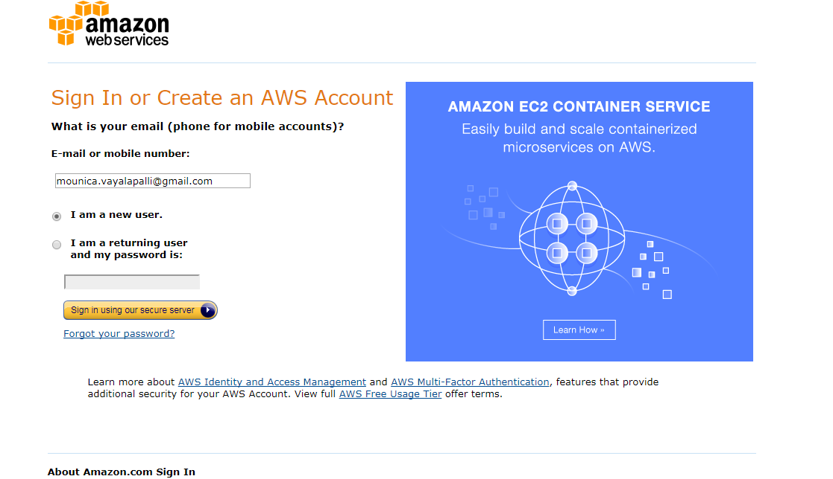

Question:

1)Create your free-tier AWS account .

You have to provide your e-mail and select “I am a new user” in provided radio options.

After that click on “Sign in using our secure serever”. Then it will redirect to next page like log in credentials.

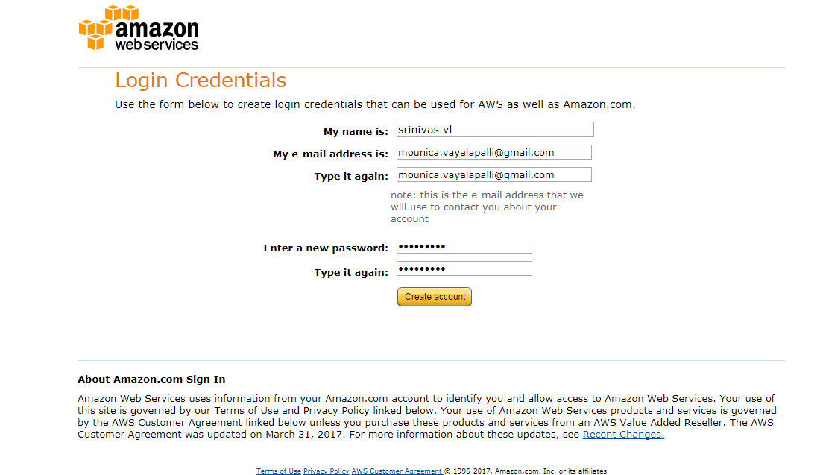

Then provide the details in your “LOGIN CREDENTIALS”.

Click on Create Account.

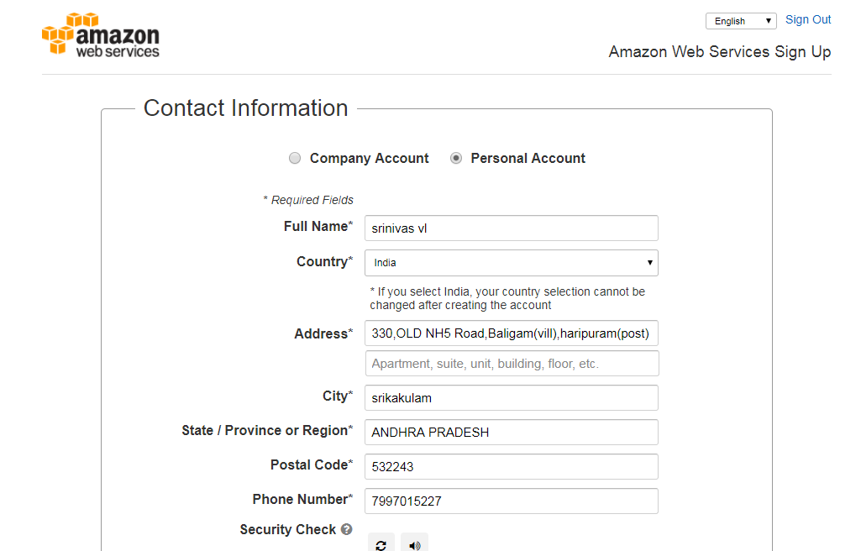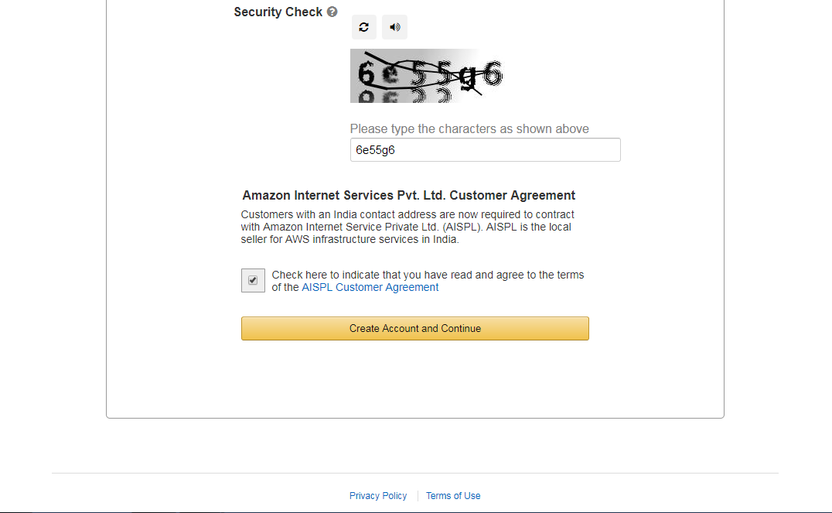

In contact information , select Personal Account(for personal uses).

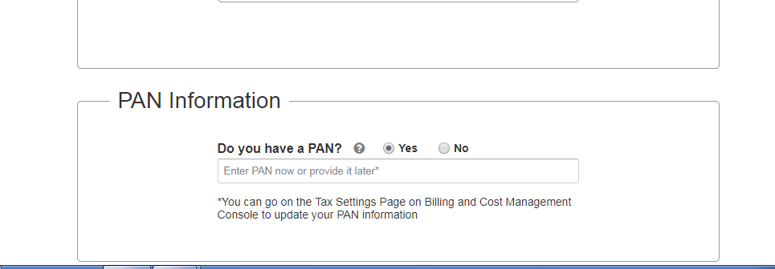provide your pan card number for more information.

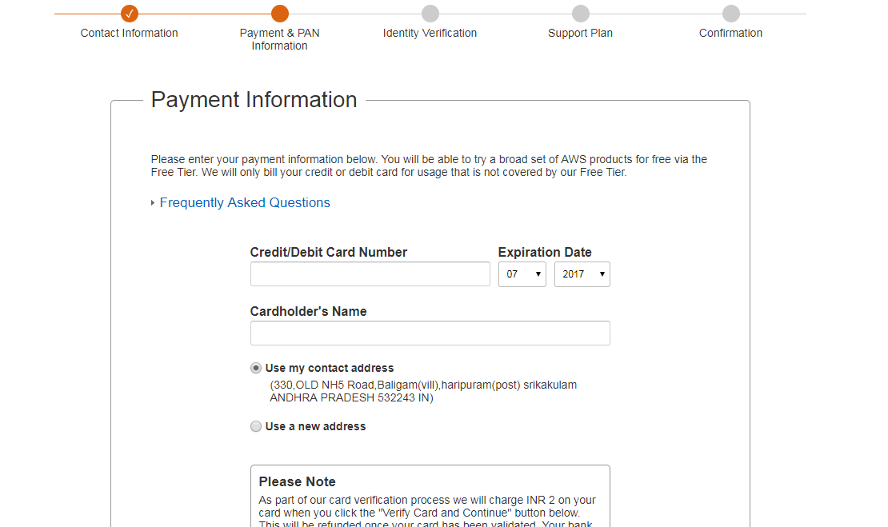

In this provide your ATM card details for the payment. Then click on verify card and continue it will check your details after that it will redirect to Identity verification.

It will ask ask your mobile number, we will get call from AWS once.it will provide one otp and we have to enter that otp in that particular voice call verification .

It will directed to support plan, for testing purpose we can select basic one. After that it will ask conformation like login through the mail link.

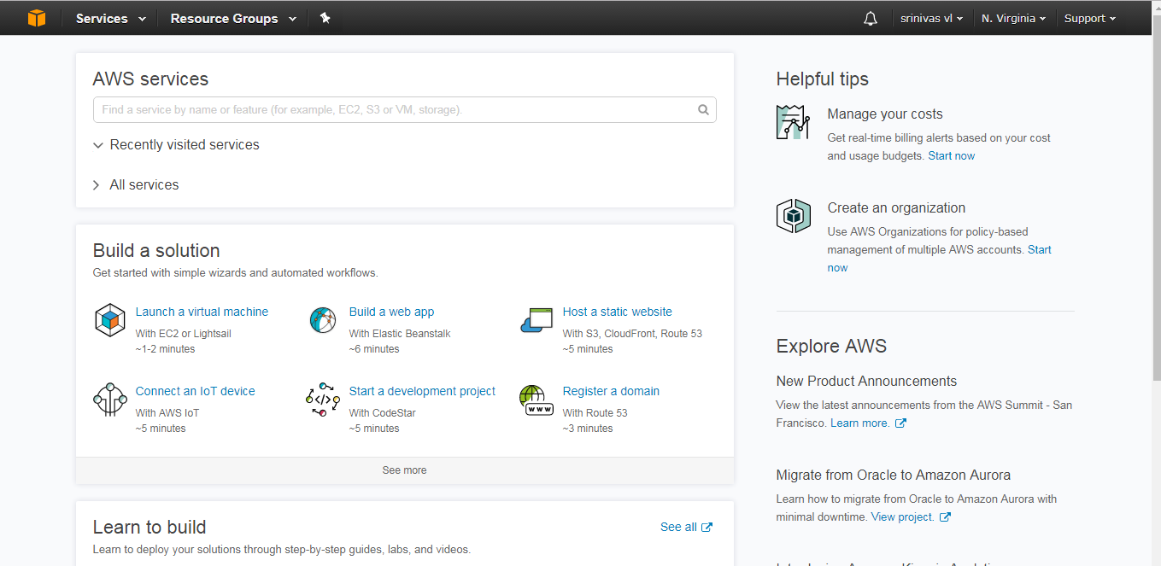

This is the new AWS account.